

OM LAB PRODUCTS
4265, Hill Road, Near Kali Bari Mandir, Ambala Cantt-133001, Haryana
Phone: +91-171-4008555
Mobile: +91-9991778111, +91-7015142342
E-mail: info@omlabs.in, enquiry@omlabs.in
Website: www.omlabs.in
GSTIN: 06AKBPG9661L1ZV

Contact us at: +91 9991778111, +91 7015142342
E-mail: info@omlabs.in
Follow us at:

- EXPERIMENT : TO STUDY THE RELATION BETWEEN FREQUENCY AND LENGTH OF A GIVEN WIRE UNDER CONSTANT TENSION USING SONOMETER.

- MATERIAL REQUIRED: SONOMETER, SET OF TUNING FORKS, SLOTTED WEIGHTS (5*500GMS), RUBBER HAMMER

Description: In this experiment we will see if the stretched wire vibrates in resonance with the tuning fork with a frequency ν, then the string also manifests the same frequency ν.

- PACKING: WOODEN BOX PACKING
- GST : A General Standard 18%
- BRAND : OM LABS

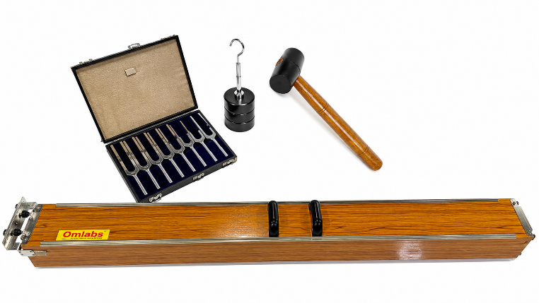

Note: Specification and image are subject to change w/o notice due to Continuous improvement
Deals in all Laboratory & Scientific Instruments.
Visit us at: www.omlabs.in

Our Youtube video link given below
https://youtu.be/u8yh5LnJKBA?si=iVjSvn6LhJjY2zx4

