
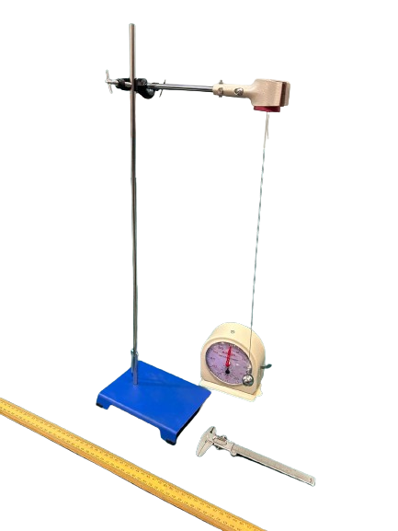


EXPERIMENT NAME :To study the variation of time period of a simple pendulum of a given length by taking bobs of same size but of different masses and interpret the result.
THINGS WE NEED: Iron retort stand, stop clock, Iron Bob, Brass bob, meter scale and vernier callipers.
SPECIFICATION :
A simple pendulum consists of a mass m hanging from a string of length L and fixed at a pivot point P. When displaced to an initial angle and released, the pendulum will swing back and forth with periodic motion.

- GST : A General Standard 18%
- BRAND : OM LABS

Note: Specifications and image are subject to change w/o
Notice due to continuous improvement.
The youtube video link given below
https://youtu.be/tYT5Js3jf3w?si=

OM LAB PRODUCTS
4265, Hill Road Near Kali Bari Road, Ambala Cantt-133001, Ambala Cantt
Phone: +91-171-4008555
Mobile: +91-9991778111, +91-7015142342
E-mail: info@omlabs.in, enquiry@omlabs.in
Website: www.omlabs.in

Deals in all Laboratory & Scientific Instruments.
Visit us at: www.omlabs.in

Contact us at: +91 9991778111, +91 7015142342
E-mail: info@omlabs.in
Follow us at:

