
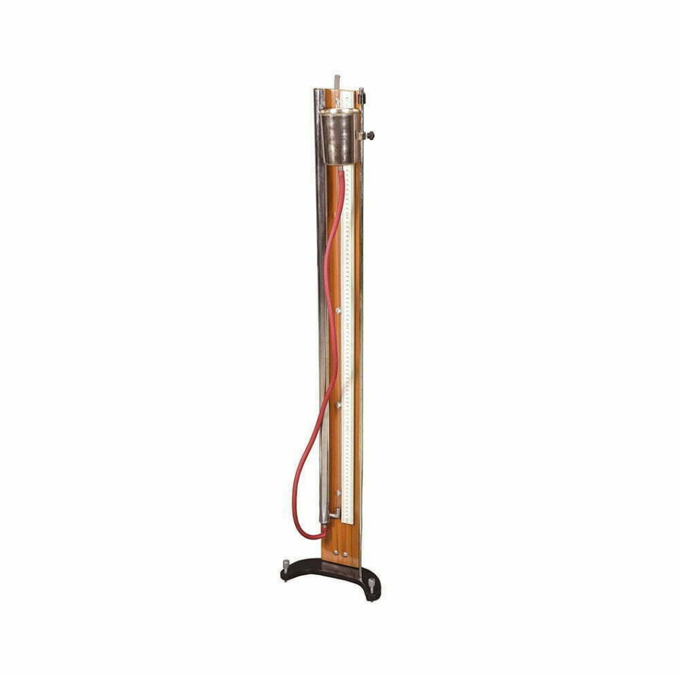


Deals in all Laboratory & Scientific Instruments.
Visit us at: www.omlabs.in
To Buy online do visit our website
www.scientifickart.com

EXPERIMENT NAME: TO STUDY THE SPEED OF SOUND IN AIR AT ROOM TEMPERATURE USING A RESONANCE TUBE BY TWO RESONANCE POSITIONS.
THINGS WE NEED:
1. Resonance tube apparatus
2. Two tuning forks of different frequency
3. Rubber Pad
SPECIFICATION :
The resonance tube experiment determines the speed of sound in air by measuring the resonant lengths of an air column and using the relationship between frequency, wavelength, and speed of sound (ν= fλ).
This apparatus having a simple stainless steel water reservoir, vertical s.s. resonance tube, a transparent plastic tube along the meter scale to read reading on the scale with a tuning fork and vertical support column complete with metric scale.
Dimensions: 47*7*6 cm approx..
Weight: 3.5 kg approx
HSN code : 9027
GST : A General Standard 18%
BRAND : OM LABS

Note: Specifications and image are subject to change w/o
Notice due to continuous improvement.
The youtube video link given below
https://youtu.be/cTvMUhwwATg?si=nO6_ltfIqnGrnD3p

OM LAB PRODUCTS
4265, Hill Road Near Kali Bari Road, Ambala Cantt-133001, Ambala Cantt
Mobile: +91-9991778111, +91-7015142342
E-mail: info@omlabs.in, enquiry@omlabs.in
Website: www.omlabs.in

Contact us at: +91 9991778111, +91 7015142342
E-mail: info@omlabs.in
Follow us at:

